Name – Abhishek Rajendra Ambekar

Project Domain - Sustainable Supply Chain Performance Dashboard Using Power BI

**Week 1 – Task**

**Step-1**

Get the Csv data and upload it in the Power BI desktop.

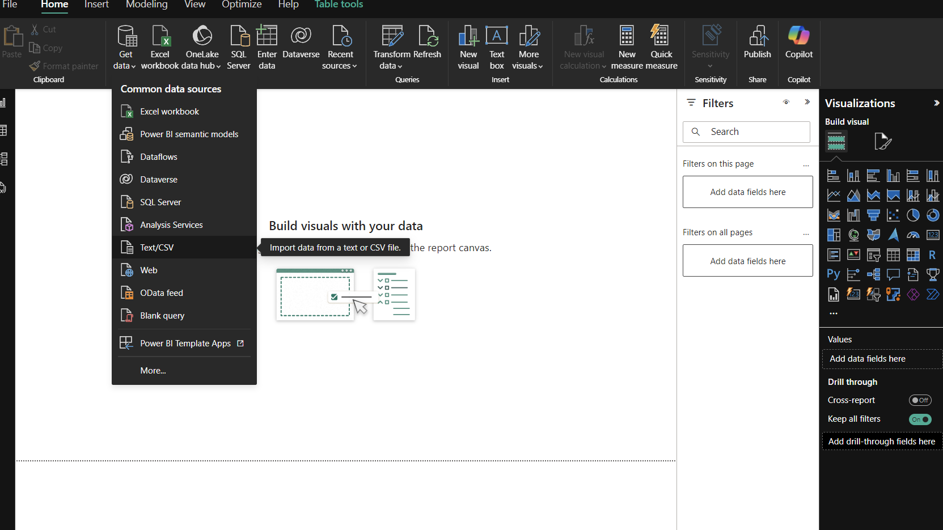

**Step-2**

Transform the Csv format data by selecting the Transform Data option.

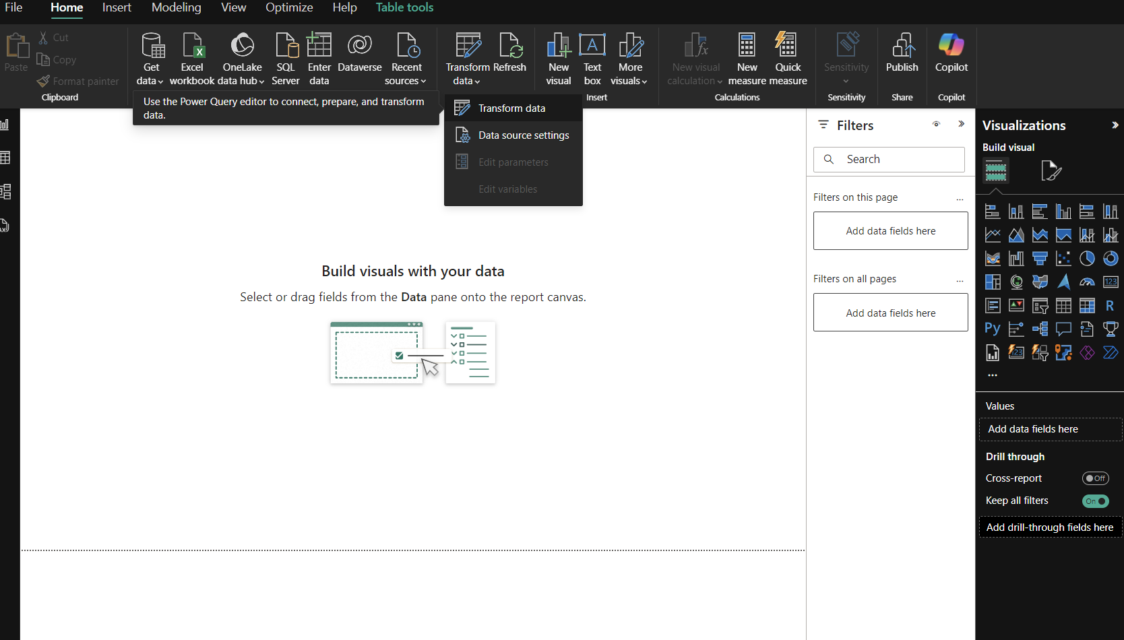

**Step-3**

Create Separate Tables as per given in the word file.

1st Table name – Inventory table

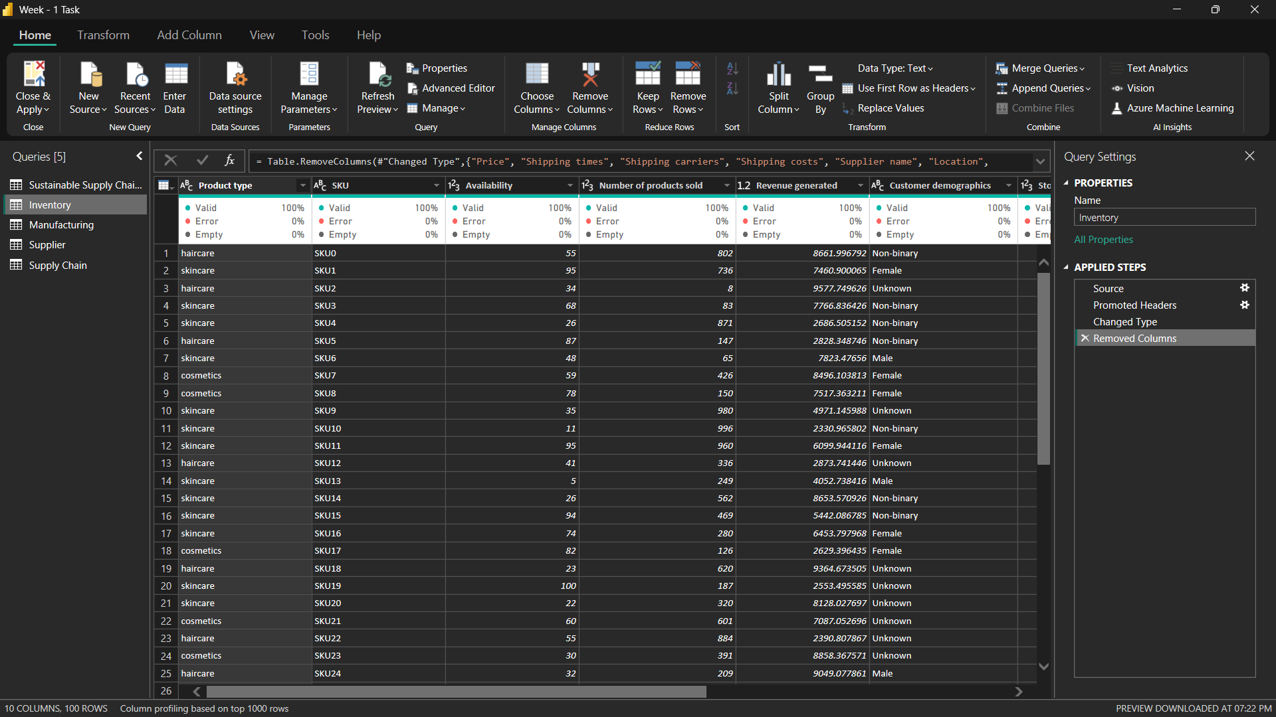

**Step-4**

2nd Table name – Manufacturing table

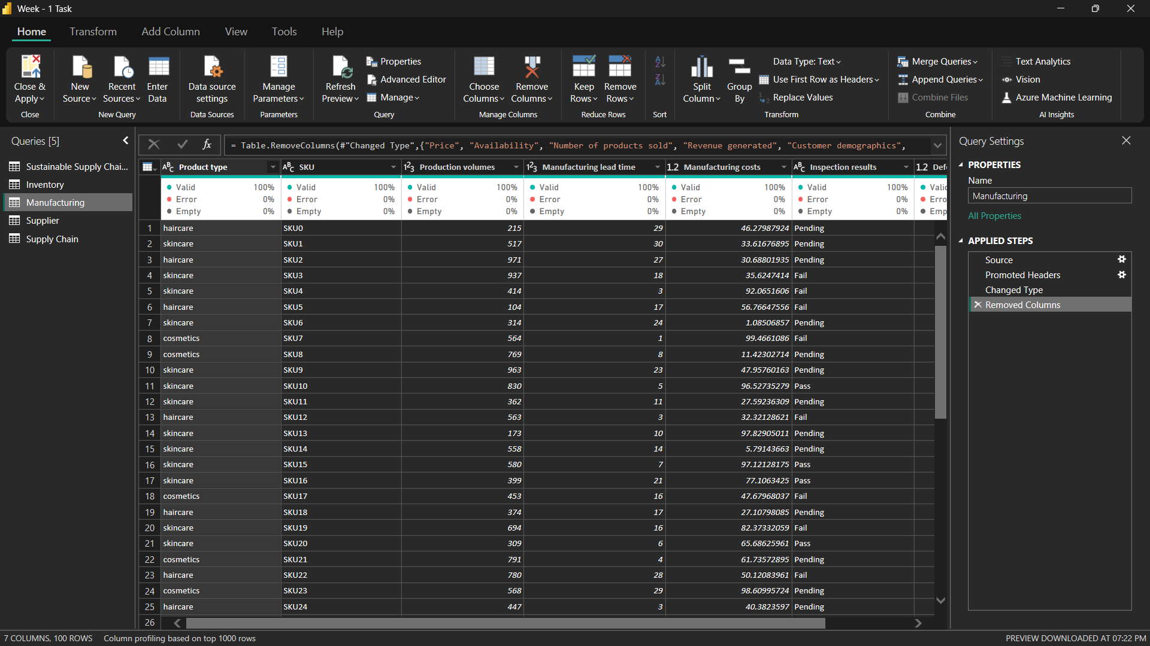

**Step-5**

3rd Table Name – Supplier Table

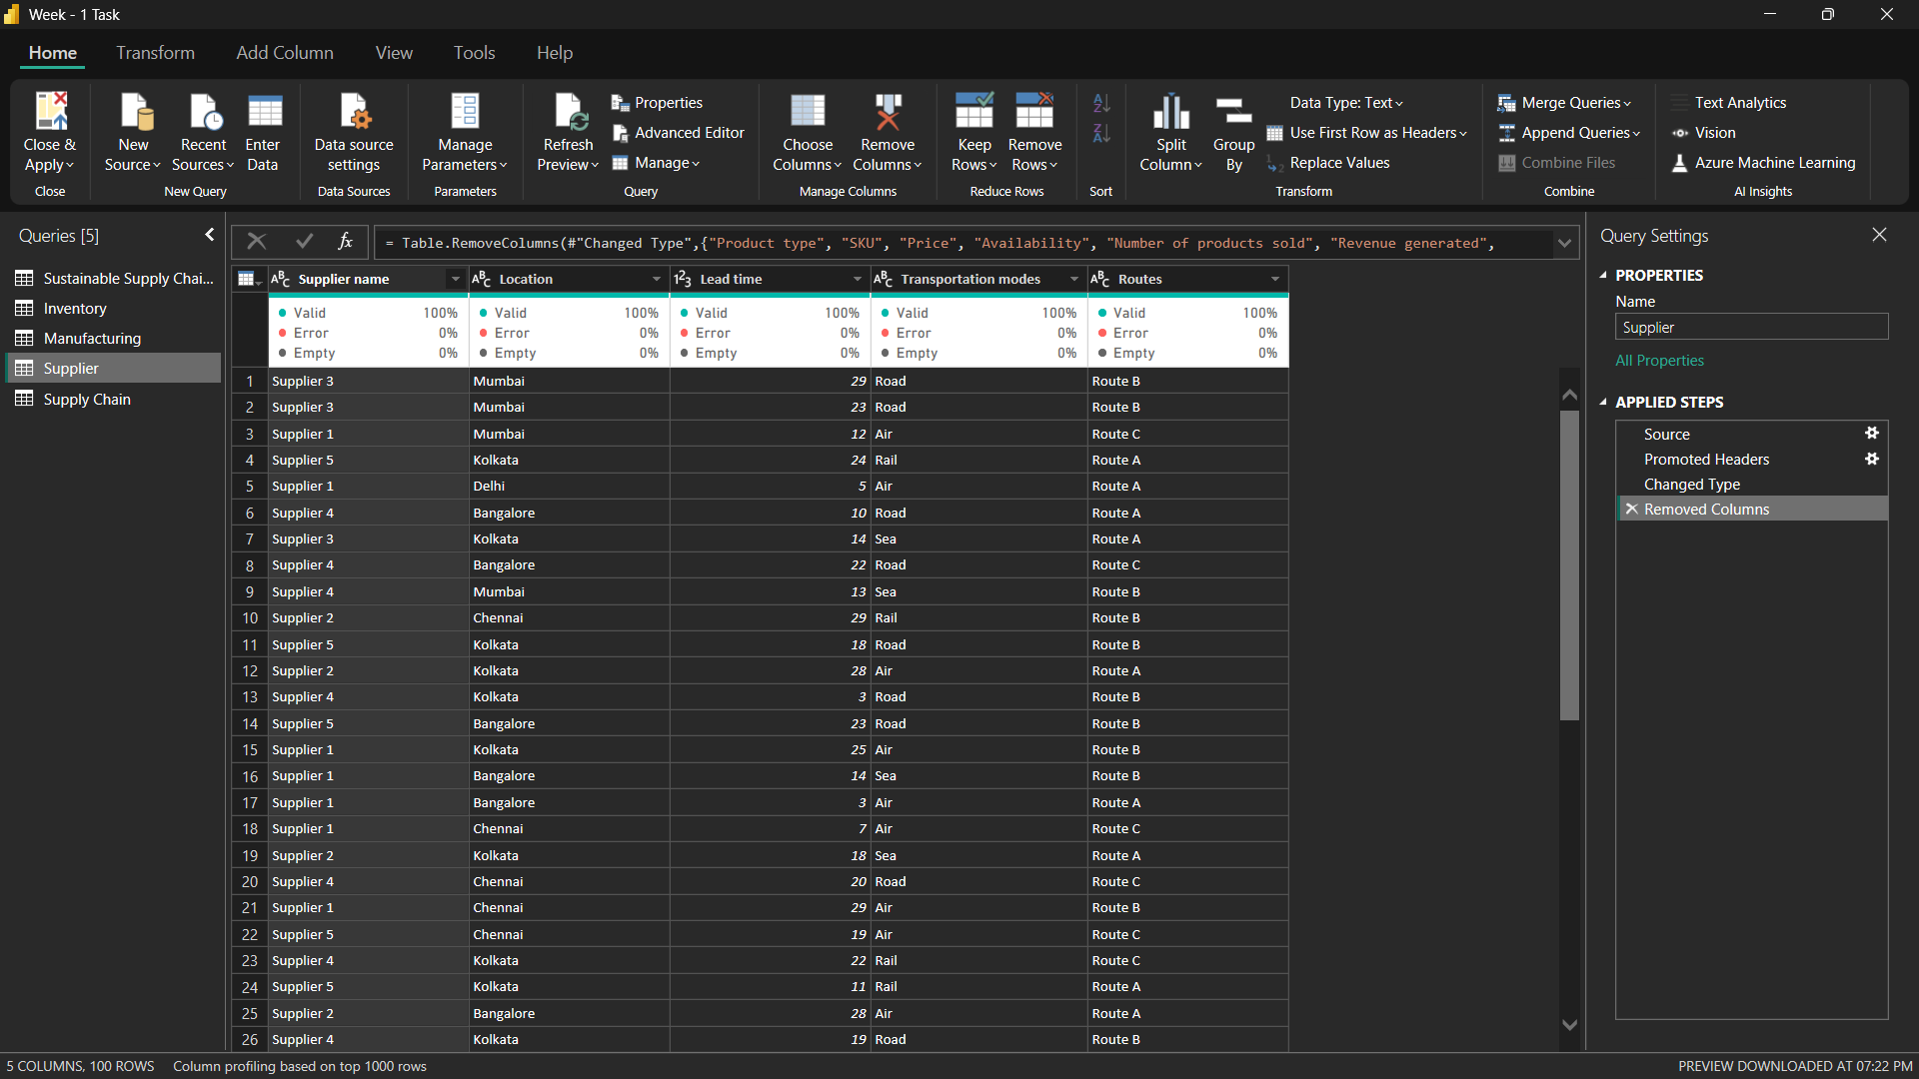

**Step-6**

4th Table Name - Supply Chain Table

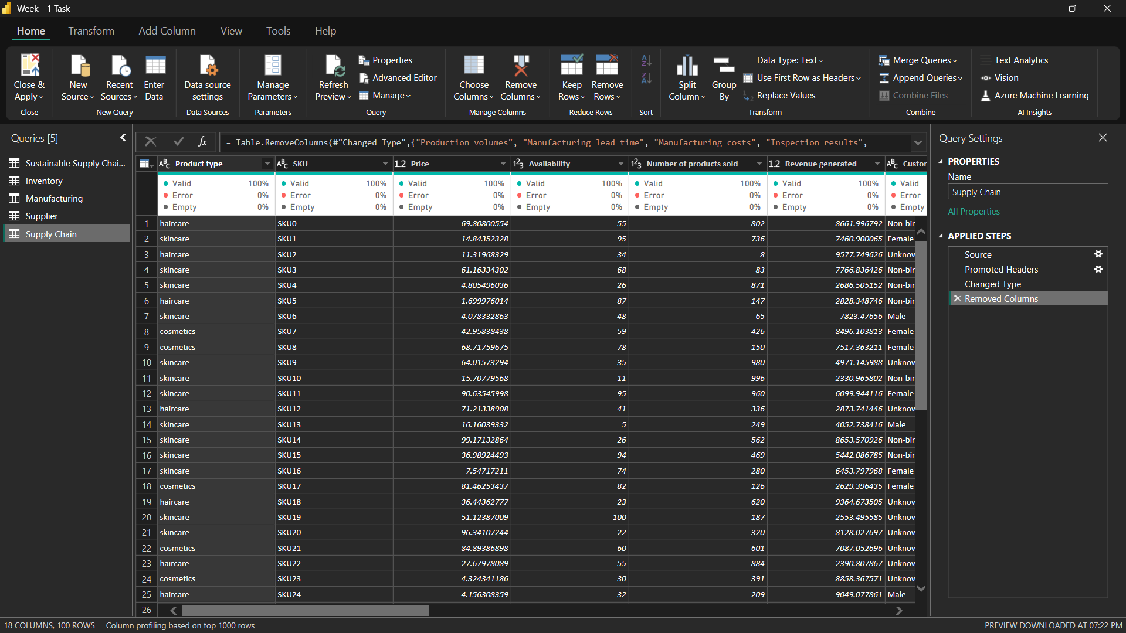

**Step-7**

Save the Task Done by Clicking the option Close & Apply.

